**Outline**

Play the original Simon game to establish a mind-set around basic game systems. Research the history of game systems. Analyze the Simon game from an input-process-output perspective.

**Objectives**

* Use the input-process-output model to solve programming problems.
* Use industry-standard programming tools (e.g., UML [Unified Modeling Language], diagrams, structure charts, flow charts, pseudocode) to develop a software project.

**Prerequisites**

|  |  |  |  |  |
| --- | --- | --- | --- | --- |
| **Prerequisite Module(s)** | **Level** | **Student Initial** | **Teacher Initial** | **Date** |
| None |  |  |  |  |

**Materials**

* Simon game obtained from teacher

**Level 0: Play the Simon Game**

Play the Simon game in your group while taking note of the following game-play items:

1. What was your personal best score? Level 7
2. What was the personal best score in your group? Level 7
3. What makes it a good game? It is a good game because it is a brain game it make you want to play more which is the main priority of every company.
4. In what ways is it similar to modern computer games? There is not much similar to modern games but there is one thing that is somewhat similar and that is the game gives you responses through something that you use your 5 senses.

Play the Simon game in your group while taking note of the following technical items:

1. How do users input information into the game? Users play transmit info into the game by pushing buttons which the game process.
2. How does the game output feedback to the players? The game inputs info to the user by audio and colored led’s
3. What are the game options for starting the game? The game options are solo or two players
4. What are the end conditions for stopping the game? You have to get the pattern provided by the game wrong to end the game and then you start a new one.

**Level 1: Simon History**

Suggested web resource: http://americanhistory.si.edu/collections/search/object/nmah_1302005

Research the history of the Simon game, focusing on the following questions:

1. Who created Simon? The people that created Simon was Ralph Baer, Howard J and Lenny Cope
2. What previous game was it based on? The previous game that Simon was based on was
3. What was the first game system? The first game system was JP_ Atari
4. What games did it have on it? The games that were on the first game system was Atari pong
5. 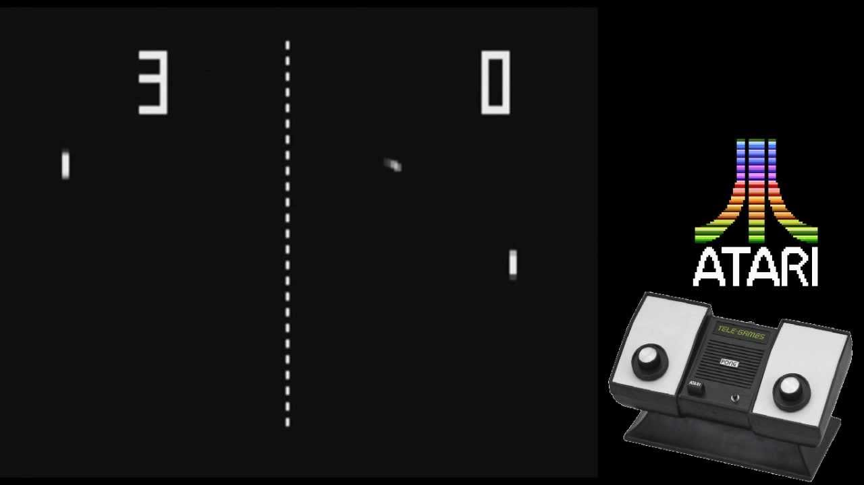

In your group, discuss the following questions:

1. What is the oldest game system you have played on? 2003 tony hawk on ps2
2. How are old games different from current games? Quality smoother gameplay and better everything
3. How are old games similar to current games? No way shape or form are the
4. d same

**Level 2: Input – Output Analysis**

1. List all of the user input objects and actions using a table similar to the one below.

|  |  |  |
| --- | --- | --- |
| **Object** | **Action** | **Description** |
| e.g. Red Button | e.g. Push | e.g. Starts the game |
| e.g. Red Button | e.g. Push | e.g. Record a step in the pattern |
|  |  |  |

1. List all of the user output objects and actions using a table similar to the one below.

|  |  |  |
| --- | --- | --- |
| **Object** | **Action** | **Description** |
| e.g. Red Light | e.g. Flash | e.g. Indicates a step in the pattern |
| e.g. Red Sound | e.g. Play tone | e.g. Indicates a step in the pattern |
|  |  |  |

1. List all of the all of the ways that an input action results in an output action using a table similar to the one below.

|  |  |  |
| --- | --- | --- |
| **Input Object** | **Output Object** | **Process Connection** |
| e.g. Red Button | e.g. Red Light | e.g. Flashes when button is pushed |
|  |  |  |
|  |  |  |

**Level 3: Flowchart Conventions**

Suggested web resource: <https://www.smartdraw.com/flowchart/>

1. Draw and explain the basic flow chart symbols.
2. Create an example flow chart that uses each basic symbol at least twice.

**Level 4: Flowchart the Simon Game**

1. Create a flow chart showing the process connections for a three-tone pattern in the middle of the Simon game.
2. EXTENSION: Create a flow chart for the whole Simon game.

**Achievement Record – Module A.1: Simon Game Icebreaker**

|  |  |  |  |
| --- | --- | --- | --- |
| **Attainment Level** | **Student Initial** | **Teacher Initial** | **Date** |
| Level 0: Play the Simon Game |  |  |  |
| Level 1: Simon History |  |  |  |
| Level 2: Input – Output Analysis |  |  |  |
| Level 3: Flowchart Conventions |  |  |  |
| Level 4: Flowchart the Simon Game |  |  |  |